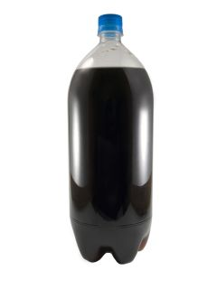
2 Liter Soda Bottle
Person
For your next book report, you will be creating a character using a 2 liter bottle. You are to decorate the bottle like the character. Write your character’s name. Then write a short paragraph describing the character. (Appearances, feelings, actions) Also pick a favorite quote from your character.

